Tepanka

Observations and Playtester Comments

# In-Game Observations

[Your thoughts as you watch the testers play]

* If you make all the right decisions in the beginning, you can win easily, but very hard if don’t choose right ones after
* Adding the way to win now makes the player actually have an objective

# In-Game Questions

Why did you make that choice? (to go into houses?)

* There was nothing else for me to do, I assumed I could go into houses since I came out of a house

What did you think that would do? (choosing one choice over another?)

* Give me better stats (she choose the empathetic choice)

What is confusing for you?

* Some choices do not seem very empathetic so I was confused which one I was supposed to choose to win the game

# Postgame Questions

[Questions you ask the testers as they have played]

* Why didn’t you make some bad choices?
  + I just played like I am myself, and I do not like making those bad choices
* So you didn’t like being evil?
  + Not really, but some choices did make me laugh

## General Questions

What was your ﬁrst impression?

* The graphics are very pretty, and the sound was cool

How did that impression change as you played?

* Stayed the same throughout

Was there anything you found frustrating?

* Not knowing which choice would give me stats sometimes

Did the game drag at any point?

* Sometimes there was a lot to read

Were there particular aspects that you found satisfying?

* The visuals were super satisfying

What was the most exciting moment in the game?

* When I won and got to leave the village

Did the game feel too long, too short, or just about right?

* A little too short

## Formal Elements

Describe the objective of the game.

* Walk around and be empathetic to become a better person and win

Was the objective clear at all times?

* yes

What types of choices did you make during the game?

* Which choice to choose, what houses to go into

What was the most important decision you made?

* Certain choices that would give me more empathy over others was important to win

What was your strategy for winning?

Did you ﬁnd any loopholes in the system?

* No, I could not spam anything

How would you describe the conﬂict?

* The evil player I am needs to learn to be human again and must be empathetic for this to happen

In what way did you interact with other players?

* NA

Do you prefer to play alone or with human opponents?

* Play alone

What elements do you think could be improved?

* Perhaps more choice options or a way to restart the game

## Dramatic Elements

Was the game’s premise appealing to you?

* Yes, I play stardew valley, which is similar

Did the story enhance or detract from the game?

* The story was basically all the game, so it enhanced it, definitely

As you played, did the story evolve with the game?

* yes

Is this game appropriate for the target audience?

* yes

On a piece of paper, graph your emotional involvement over the course of the game.

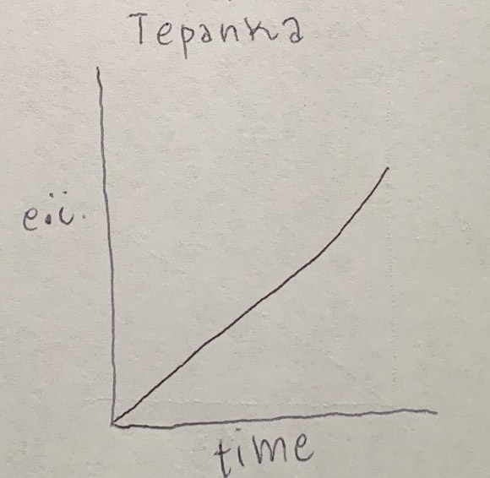

Did you feel a sense of dramatic climax as the game progressed?

* Not really, no

How would you make the story and game work better as a whole?

* Maybe have a climax or something?

## Procedures, rules, interface, and controls

Were the procedures and rules easy to understand?

* yes

How did the controls feel? Did they make sense?

* Very smooth, made complete sense

Could you ﬁnd the information you needed on the interface?

* yes

Was there anything about the interface you would change?

* Maybe add a little map or something

Did anything feel clunky, awkward, or confusing?

* no

Are there any controls or interface features you would like to see added?

* A little map, and maybe a run

## End of Session

Overall, how would you describe this game’s appeal?

* Explorer game to level up stats and become more likeable

Would you purchase this game?

* As a gift, sure

What was missing from the game?

* Maybe a battle system?

If you could change just one thing, what would it be?

* Adding a climax or something other than reading

Who do you think is the target audience for this game?

* children

If you were to give this game as a gift, who would you give it to?

* My little brother

# Revision Ideas

[Ideas you have for improving the game]

* Add a way to restart the game